FELTHORPE PARISH COUNCIL Parish Clerk:
Sonya Blythe,
36 Acres Way,
Drayton,
Norwich, NR8 6UT
Telephone: 01603 527095
Email: felthorpe_pc@yahoo.co.uk.

CONTRACT FOR:
Grounds Maintenance

CLOSING DATE:
Thursday 18 February 2016
Felthorpe Parish Council
Grounds Maintenance Contract
April 2016 – March 2018 (with an option to extend for a further year if both parties are in agreement).

Quotes are invited from competent persons to undertake grounds maintenance in the parish of Felthorpe.
Bidders are recommended to contact Bob Clarke, Chairman of the Parish Council, for a viewing of the areas in question before quotes are submitted (01603 755430, bobandriet@talktalk.net).
All bids are to be marked in a plain envelope for the attention of the parish clerk and clearly marked GROUNDS MAINTENANCE CONTRACT in the top left hand corner, so that the tendering process will not be prejudiced.
You should also enclose the following:
- Copies of public and employers liability insurance should be submitted with the tender document.
- Method statement (Description of equipment used, number of operatives carrying out the work, short description of how you intend to fulfill the terms of the contract).
Closing date for receipt of returned bids is 6pm on Thursday 18 February 2016. The winning bid will be announced following the council meeting of Tuesday 1 March 2016 and the winning contractor will be expected to commence from 1 April 2016.
Contractors are reminded that any canvassing etc. will immediately disqualify any quote submitted.
The parish council is not obliged to accept the lowest quote.

THE COUNCILS RESERVES THE RIGHT TO CANCEL ANY CONTRACT AT ANY TIME, WITHOUT COMPENSATION, SHOULD THE FOLLOWING SPECIFICATION NOT BE ADHERED TO.

Specification
- Dependent on growth rate extra cuts can be ordered, in addition to those on the attached schedule of work. In exceptional circumstances or severe drought conditions grass cutting may be suspended, with the program resuming when ground conditions improve.

- In general, grassed areas are to be cut to approximately 30mm in height, allowing for a maximum growth height of 60mm between cuts.
- Before each cut, the contractor is required to remove any litter in order to avoid it being shredded by the mowers.
- After mowing, cuttings should be swept or blown back onto the grass and off adjacent roads and paths.

- To remove the element of doubt the contractor will be expected to trim or strim grass around all street signs, seats, and trees that are within the areas marked in red on each cut.

- All operations are to be undertaken in such a way as to cause as little disturbance to the public as possible, including working considerate hours.

- All due care must be taken whilst mowing or strimming. Any damage or injury caused must be reported to the parish clerk immediately.

- The operator must have a current PT6 certificate for any herbicide use within the contract area.

- The Contractor must provide all necessary equipment and personnel to perform the job, and provide method statements to cover all aspects of Health and Safety. If not available the parish council will provide a proforma method statement for the contractor to complete.
- The contractor will be expected to submit a monthly itemised bill via email or in hard copy to the parish clerk. This will then be agreed and paid by cheque at the next meeting of full council, held monthly.

Guidance

- Quotations are to be submitted exclusive of VAT.
- The Contractor shall include in the tender for everything necessary to complete the works.
- The Contractor shall comply with the Health and Safety at Work regulations and all other statutes and regulations. Operatives must wear high visibility clothing incorporating additional reflective materials for extra safety, boots with steel toe-caps and, where appropriate, helmets, all to be provided by the Contractor.

- Before the contract can commence, the successful Contractor shall supply a copy of the current public liability insurance policy, a risk assessment and two references of clients. The contractor will be expected to provide copies by email of all insurance policies at their renewal anniversary to the clerk to prove continuity.

- The contract will run for a period of two years, ie from April 2016 until March 2018. There will be an option to extend this contract at the same value if the council are satisfied with the standard of work after this period. However any extension will be for 12 month periods only and terminable at the end of each growing season.

- Tenderers are invited to provide added value items to their bids to be included in the price per cut. i.e improving areas currently unmaintained, fallen wood/leaves, moss treatments or other enhancements to the schedule that will further improve the appearance of the village in general. Any added value items offered will be added to the schedule/contract and be binding.

- The council reserves the right to clarify any statements on submitted tenders and specifications with contractors before making any decision.
- The Contractor shall at all times maintain in force such policies of insurance, with reputable insurers or underwriters approved by the Council, as shall fully insure against such risks as the Council in its absolute discretion may require and indemnify the Council against any damage, loss or injury which may occur to any property or to any person by or arising out of or in connection with the provision of the service in the minimum sum of £5million for any one claim for property damage, unlimited for personal injury.
- The council reserve the right to add or remove areas to be cut during the period of the contract and the contractor will be invited to provide a cost/reduction where applicable in writing to the clerk. This will then be added to the schedule and be a binding part of the contract.

- The council will not be liable for any damage or loss to equipment incurred by the contractor during the period of the contract howsoever caused. The contractor is expected to survey each area before cutting commences to ensure no obstacles or stones are present.

Schedule of Work

Area 1 Grass Verges (maps page 6-8)
- To trim and keep tidy (fortnightly May to September, and monthly in March, April, October and November).
- To cut all grassed areas on a fortnightly basis

Area 2 Village Well (map page 8)
- To trim, sweep and keep tidy as required (April, July and October).

Area 3 Footpath Maintenance (map page 9)
- Chapel Lane to Church Lane - strim four times per annum (April, June, August and November).

Maps
- Grass Cutting
Map 1 – Corner Bilney Lane and The Street
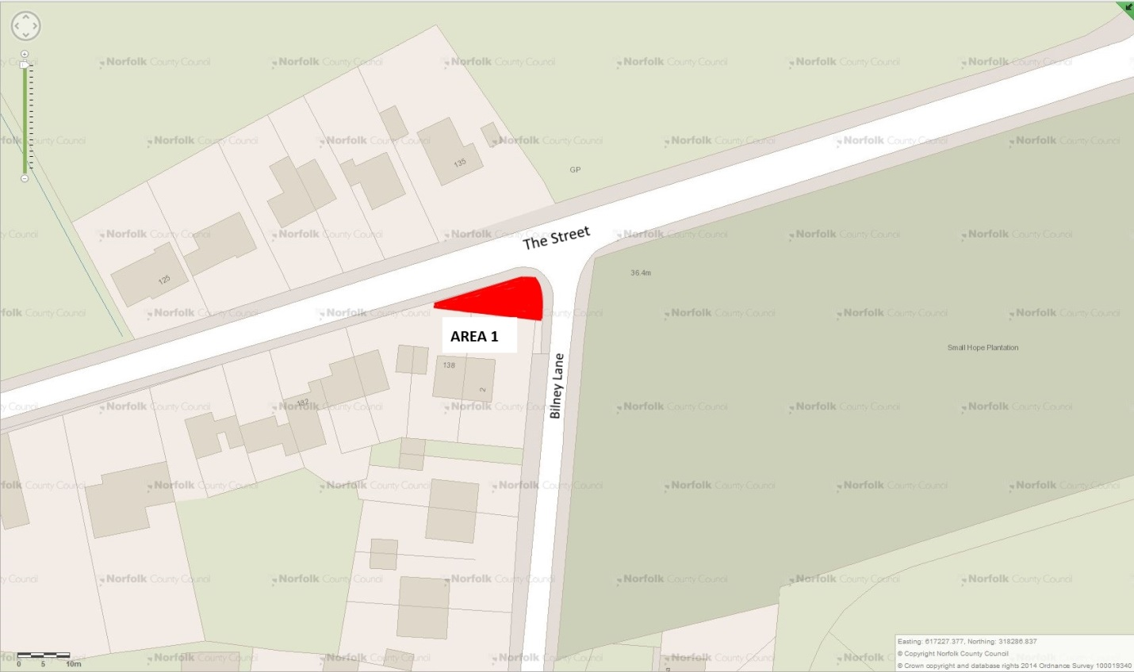

Map 2 – Corner Nash Road and The Street including Bus Shelter
Map 3 - Corner Nash Road and The Street (East)
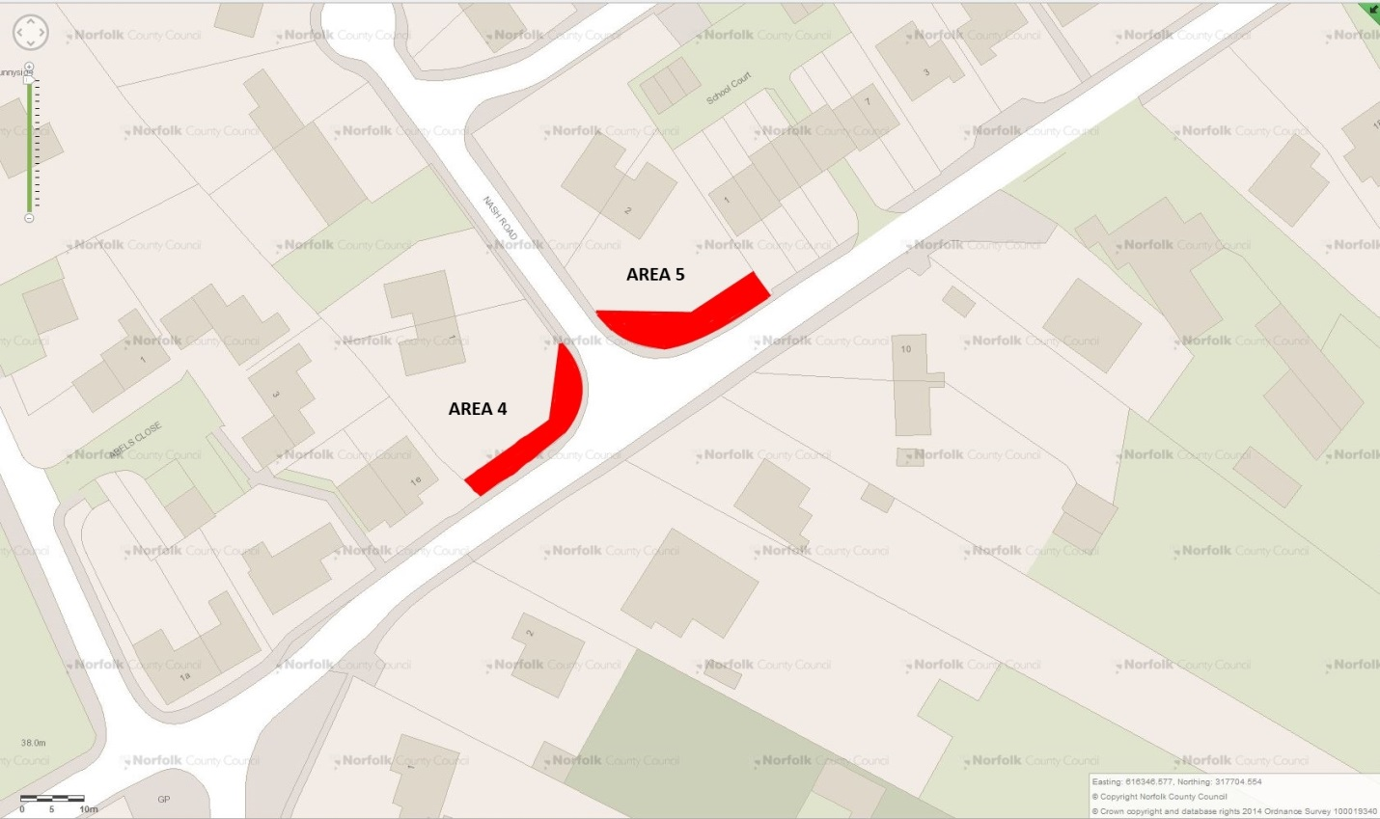
Map 4 – Corner The Street and Taverham Road by Village Sign
Map 5 - Corner The Street and Taverham Road (East)
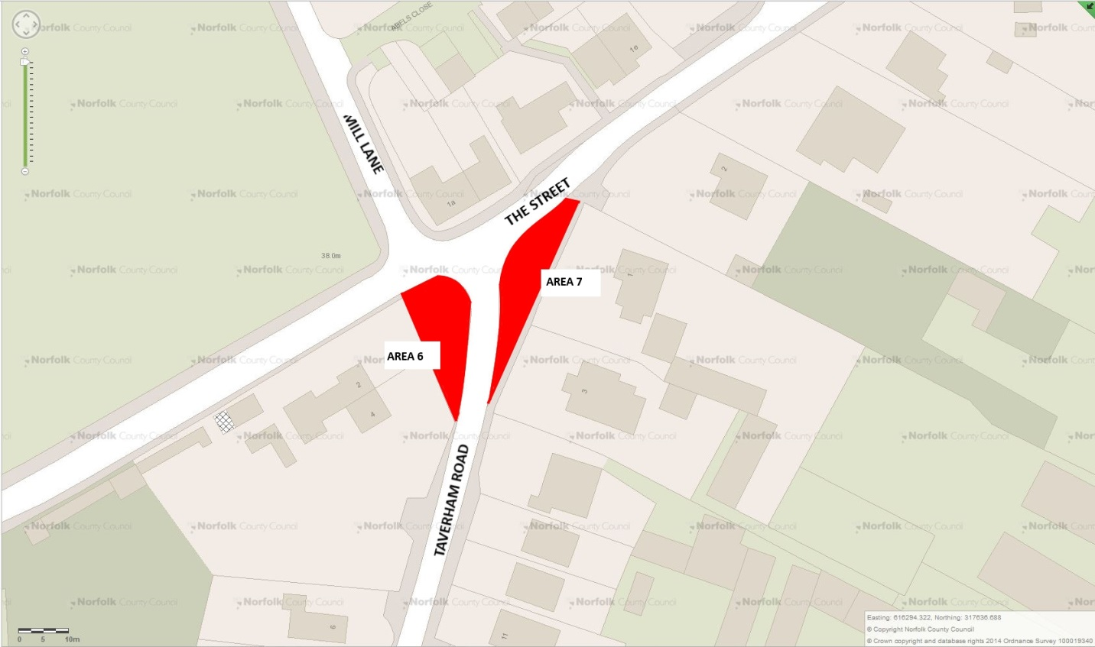
Map 6 – Corner Church Lane and Taverham Road
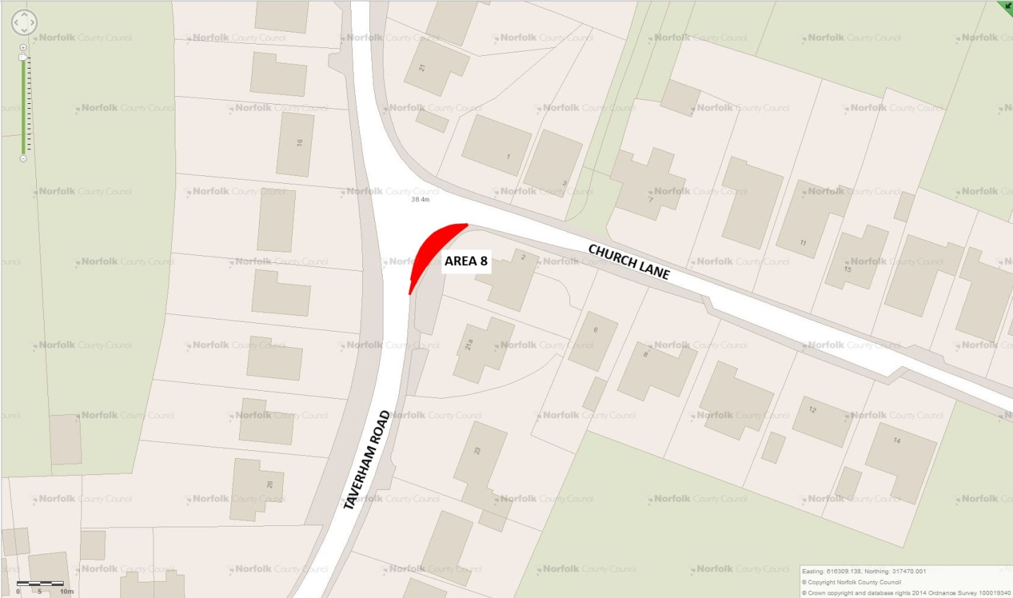

Map 7 – Reepham Road and Furze Lane Junction
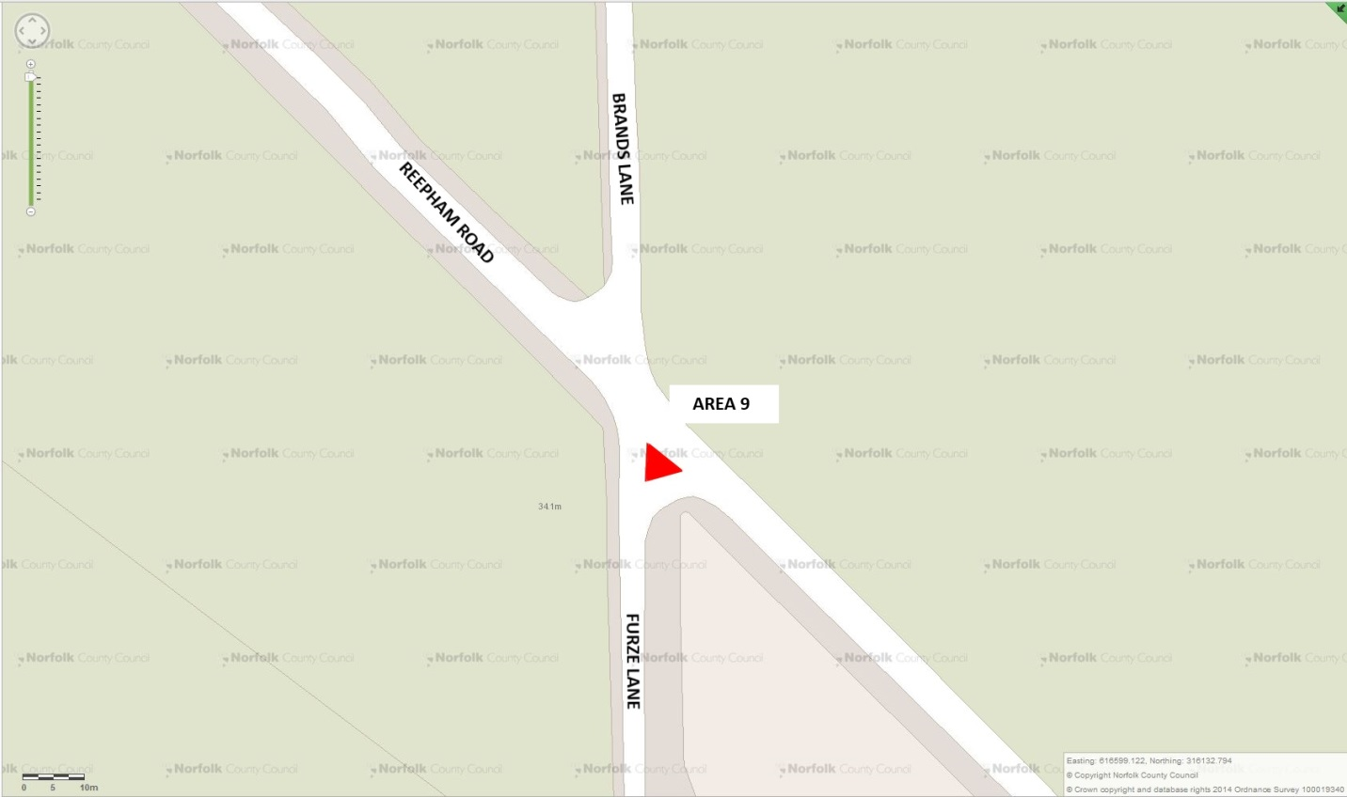

- Village Well
Sweep and keep tidy. Trim overhanging trees and shrubs
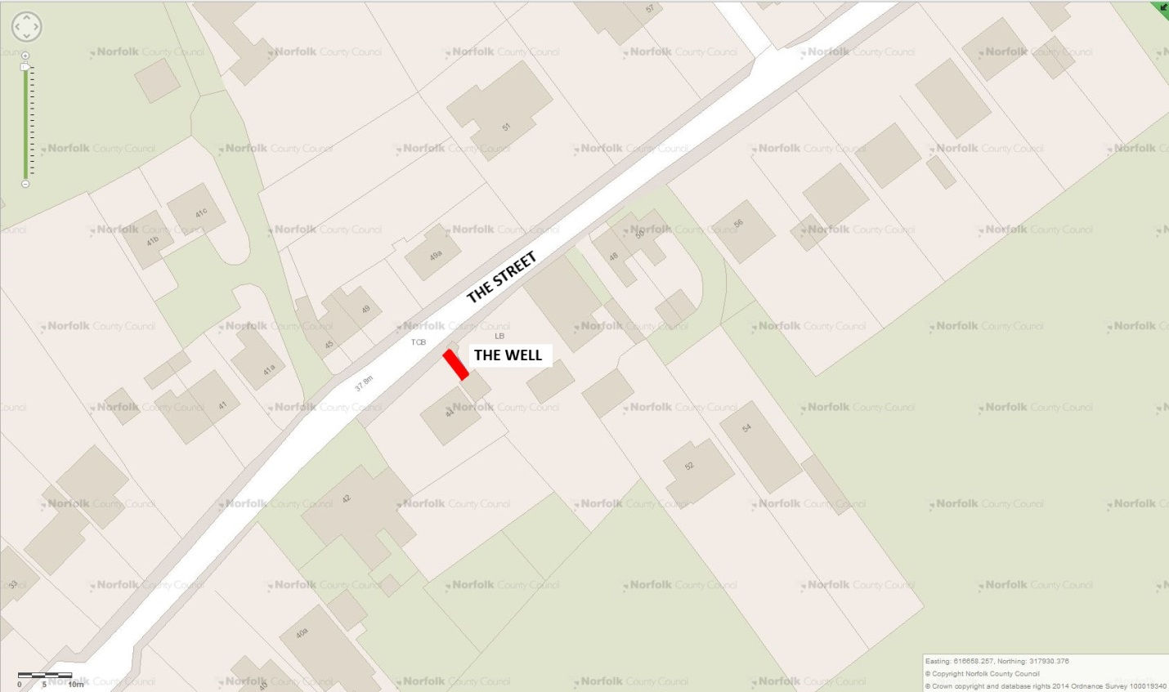

- Public Footpath Maintenance
Chapel Lane to Church Lane to be strimmed four (4) times per year.
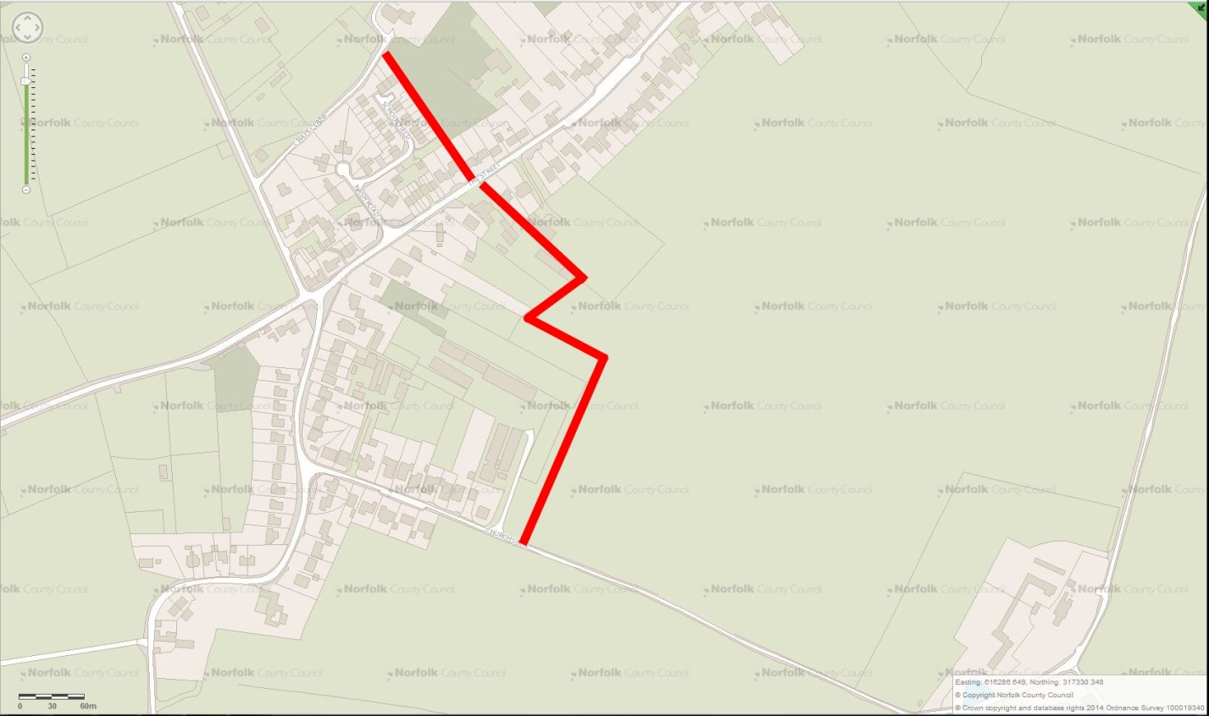

Tender Form
Frequency as per the Schedule of Work and Specification.
1. | GRASS CUTTING
 | Map 1 – Corner Bilney Lane and The Street
 | £ | PER CUT inclusive
 | Map 2 – Corner Nash Road and The Street including Bus Shelter
 | £ | PER CUT inclusive
 | Map 3 - Corner Nash Road and The Street (East)
 | £ | PER CUT inclusive
 | Map 4 – Corner The Street and Taverham Road by Village Sign
 | £ | PER CUT inclusive
 | Map 5 - Corner The Street and Taverham Road (East)
 | £ | PER CUT inclusive
 | Map 6 – Corner Church Lane and Taverham Road
 | £ | PER CUT inclusive
 | Map 7 – Reepham Road and Furze Lane Junction
 | £ | PER CUT inclusive
2. | VILLAGE WELL
 | £ | PER VISIT inclusive
3. | PUBLIC FOOTPATH MAINTENANCE
 | £ | PER CUT inclusive
Included within the cost we are prepared to carry out the following works in order to enhance the appearance of the village, for example cleaning the village sign annually or mole eradication..
6a
£
6b
£

PERFORMA INVOICE

To: Felthorpe Parish Council
Date:
Grounds Maintenance for the Period | DD/MM/YYYY | To | DD/MM/YYYY

 | Description | Rate | Quantity | Amount
1. | Grass Cutting
 | Map 1 | £ |  | £
 | Map 2 | £ |  | £
 | Map 3 | £ |  | £
 | Map 4 | £ |  | £
 | Map 5 | £ |  | £
 | Map 6 | £ |  | £
 | May 7 | £ |  | £
 | Subtotal Grass Cutting |  |  | £
2. | Village Well | £ |  | £
3. | Public Footpaths | £ |  | £
4. | Itemized Additional Items |  |  | £
 |  |  |  | £
 | Total Due This Invoice |  |  | £
 | Total Payments (Including this Invoice) |  |  | £

