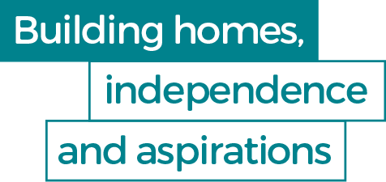

4women Outreach Service
Introduction:
4women is a service of Home Group a social enterprise and a charity; it is one of the UK’s largest providers of high quality housing and integrated housing, health and social care organisations.
Based in Norwich, the 4women service supports women of Norfolk, including the most vulnerable. The service works closely with various partner organisations, including the Criminal Justice System, to provide advice, support and activities.
4women Outreach Support is a new service aimed at women aged 18 years and above, living in the ‘Wensum & Coast’ and ‘The Broads’ areas, and who are long-term unemployed, furthest from the labour market and isolated through rural location.
The 4women team will be providing localised support and activities across the designated areas. Led by women, for women, the team is ambitious in its achievements and for the women accessing new project support.

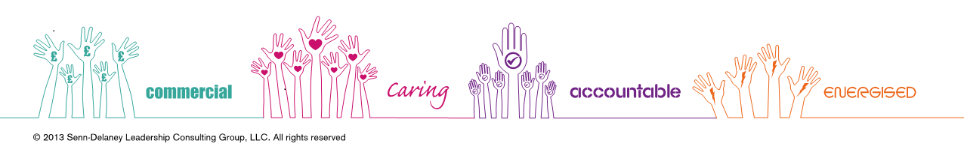

4women Outreach Service:
Individual assessment and support delivered against an agreed Action Plan providing coaching and mentoring to support women achieve their goals;

Small sized group sessions, each held over two sessions of two hours duration: ‘MY FUTURE CHOICES’ helps women develop self-confidence, identify their skills and undertake a career aptitude test which identifies jobs against personal skills, and CV planning, personal profiles, completing application forms and mock interviews; ‘REACH FOR SUCCESS’ looking at interview styles, interview scores, mock interviews, examples of interview questions and preparation for interviews; and ‘INTRODUCTION TO SELF-EMPLOYMENT’ looking at personal characteristics useful for self-employment as well as personal profile, business and personal skills, support networks, pros and cons of being self-employed, the barriers to self-employment and how to overcome them to run a successful business.

Individual/group-work delivery of Home Group’s Home Achievement Programme providing modular learning across a range of relevant subjects and enabling women to gain a qualification at Level 1, accredited by the national awarding organisation, One Awards. Examples of some of the modules we offer are:
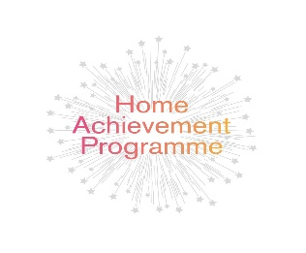
* Personal Goals and Career Ambitions * Identifying Volunteering Opportunities
* Understanding Business Essentials * Developing a Positive Mind-set

Links to local volunteering opportunities, local employers, including Micro and Small businesses, across a range of work sectors as well as opportunities with Home Group’s ‘Inspiring Futures’ Apprenticeship Scheme.

Sector-Based Work Academies with the potential for women-only Academies to promote “job-ready” women, delivered in partnership with Job Centre plus

Opportunities to become an Employability Ambassador providing peer support to other women at the start of their own personal journey.
4women’s Outreach Service is aimed at women who…

Have experienced past trauma, poor mental and/or physical health including disabilities, substance/alcohol misuse, unsettled housing and who want to return to the employment market. The project is particularly keen to hear from women aged 50 years+ who are considering returning to work, women with caring responsibilities and women wanting to improve their skills.

Are available for, and eligible to work in the UK

Aged 18 years+

Live within ‘The Broads’ or ‘Wensum & Coast’ areas – please telephone to check customer eligibility

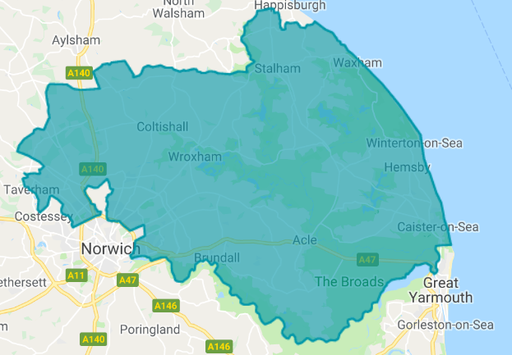 The Broads
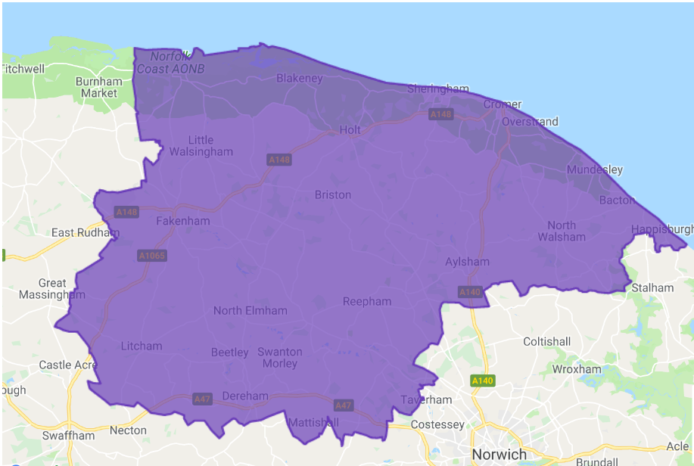 Wensum & Coast

Contact Us
To speak to a member of the Outreach Team, please telephone:

Aleksandra Burzec on 0746-4676-743
Kelly Jones on 0774-1900-624
Or email 4womenoutreach@homegroup.org.uk

To speak to a member of staff at the 4women Service:

Telephone 0300 131 7983

The project is supported by a range of funders including Norfolk County Council’s ‘Local Investment in Future Talent-LIFT’ Fund, European Social Fund, New Anglia LEP’s ‘Community Challenge Fund’ administered by Norfolk Community Foundation and Norwich Charitable Trusts.

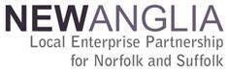

@homegroup www.facebook.com/HomeGrouphousing

