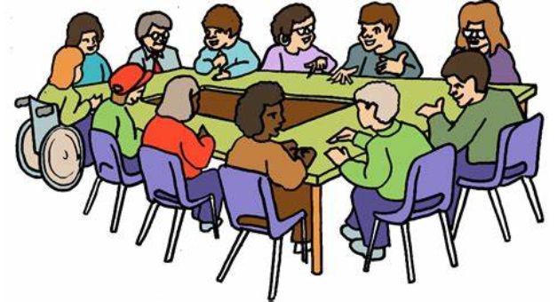  - Be extraordinary  Become a Local Councillor  Parish councils make all kinds of decisions on issues that affect the local community. Probably the most common topics that parish councils get involved with are planning matters (they are statutory consultees), crime prevention, helping local groups, managing open spaces and campaigning for and delivering better services and facilities.  Local elections take place on Thursday  4th May 2023 are you willing to put yourself forward?  The last date for nominations is:  4 pm Tuesday 4th April 2023.  Nominations will be published by:  4 pm Wednesday 5th April 2023.  FELTHORPE PARISH COUNCIL  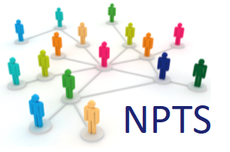
  Would you like to:
  ____
  Make a difference to local people’s lives?
  ____
  Give something back to your community?
  ____
  Help shape your community for the benefit of all its residents?
  ____
  Make Felthorpe a great place to live?
  For more details contact:
  felthorpe_pc@yahoo.co.uk
  https://felthorpeparishcouncil.norfolkparishes.gov.uk/

